|  |  |
| --- | --- |
|  | **English 4**  Semester 1 Credit Recovery Opportunity  Springboard |

**Option 1: Unit 2, Embedded Assessment 2**

**Applying a Critical Perspective**

Assignment:

Your assignment is to write an analytical essay applying the Feminist Critical Perspective to a short story. You have two stories to read and choose from, “The Story of an Hour” by Kate Chopin or “The Chaser” by John Collier. (Both stories are included.)

|  |  |
| --- | --- |
| Planning and Pre-Writing | * Which of the two stories resonates with you on a personal level? * What questions are asked about a text when it is read from a feminist perspective? * How will you collect your initial ideas to create a focus on feminist perspective of these stories? (e.g., brainstorming, a graphic organizer)? * How will you determine which ideas should go into your draft? * Who is the audience for your essay? How much do you think this audience knows about feminist issues and feminist criticism? |
| Drafting | * How much summary is necessary to introduce the story to the audience? * How can you summarize and paraphrase the text in a way that keeps the author’s original meaning? * How will you use both evidence from the text and your own words to support your feminist perspective? * How can you make sure that your writing is clear and engaging to the reader (e.g., using appeals, sentence variety, transitions between ideas)? |
| Evaluating and Revising | * How can you determine if your syntax and use of language helps the reader understand your feminist analysis? * How will you determine if your sentence structure and transitions present your ideas in the best way? * How can you use the Scoring Guide to help evaluate your draft and guide your revision? |
| Editing and Publishing | * How will you check for grammatical and technical accuracy? * What tools are available to you to create a technically sound text (e.g., dictionary or format guide, spell check)? |

Reflection:

After completing this Embedded Assessment, think about how you went about accomplishing this assignment, and respond to the following:

* How did your understanding of Feminist Criticism shape your analysis of the short story?

Resources:

This Embedded Assessment is the culmination of Unit 2, Part 2. This portion of the unit begins on Page 240 of the English 4 Student Edition.

Scoring Guide:

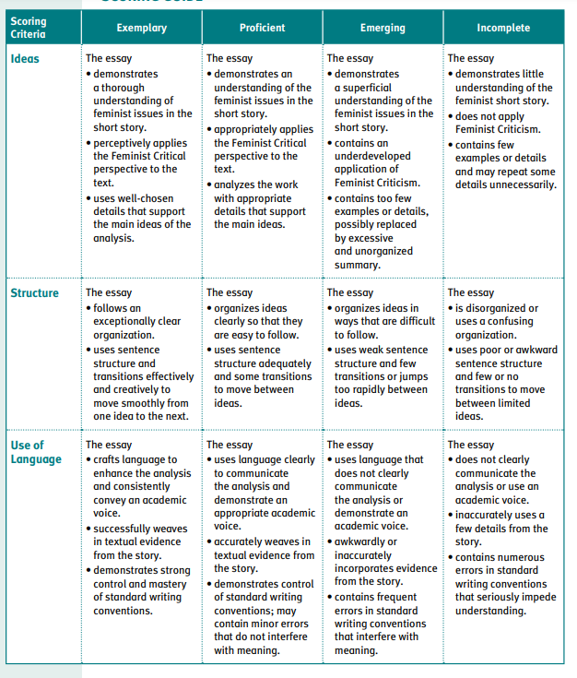

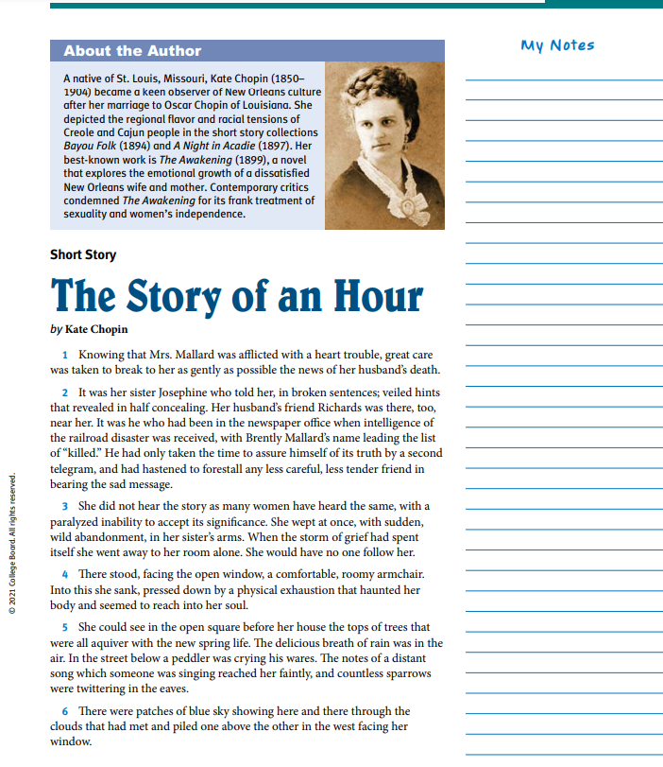

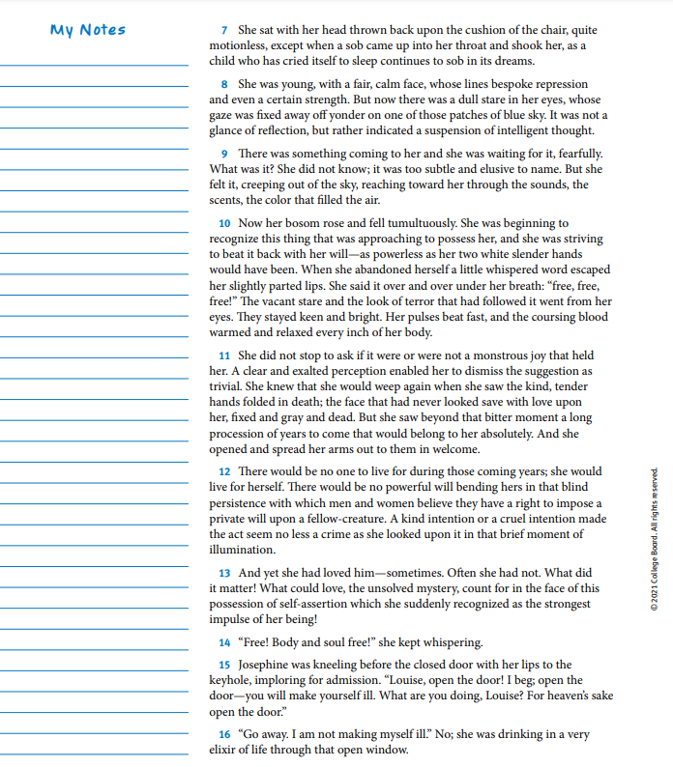

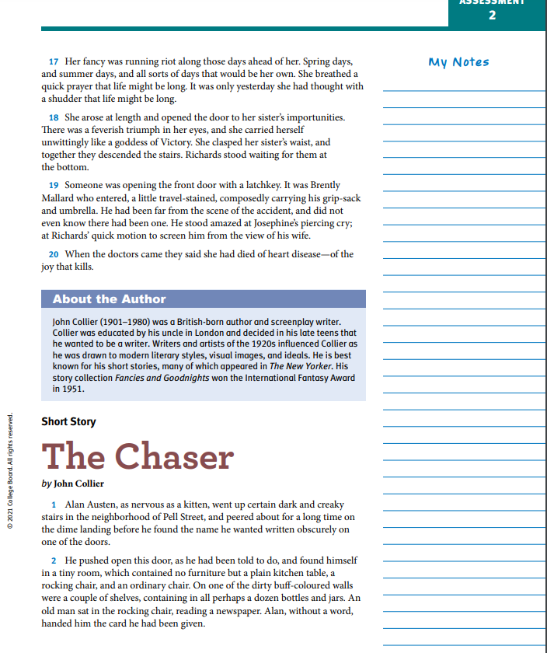

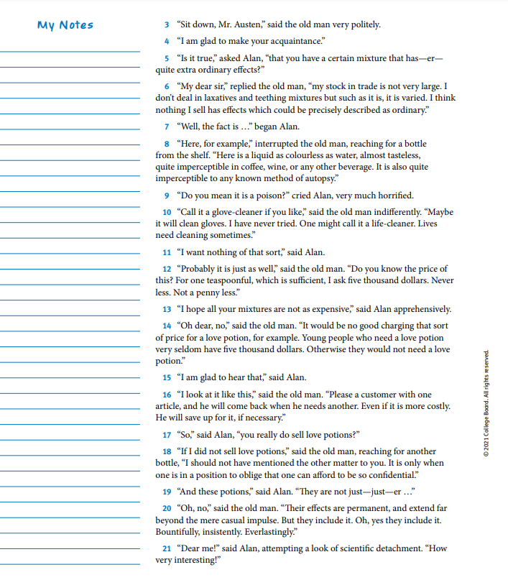

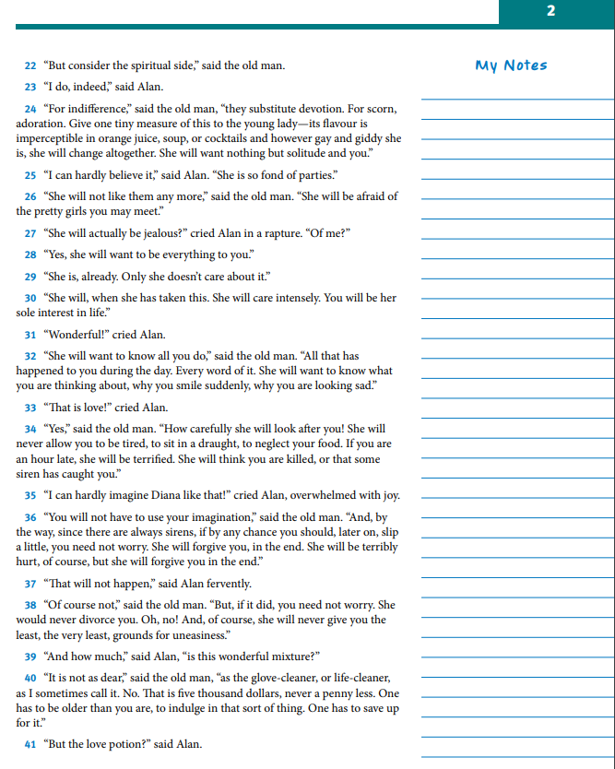

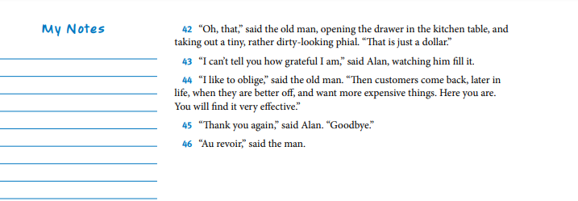

**Option 2: Springboard Writer’s Workshop Argumentative Essay**

Argumentative Response

Learning targets:

* Analyze the characteristics of argumentative writing, and evaluate a writer’s use of reasoning and evidence to support a claim.
* Use knowledge of the writing process to plan, write, revise, and edit an argumentative essay that supports claims with valid reasoning and relevant evidence.
* Introduce and develop claims and counterclaims effectively, anticipating the knowledge, concerns, values, and possible biases of the audience.
* Use an organizational structure and transitional words, phrases, and clauses that make the relationships between claims, counterclaims, reasons, and evidence clear and cohesive.
* Edit drafts to conform to standard English conventions.
* Participate collaboratively during discussions by contributing relevant ideas and information, building on others’ ideas, and moving the discussion forward with thoughtful questions and responses.

Activity 1: Discovering the Elements of an Argumentative Response Essay

Engaging Online

1. The internet is a fantastic place to find and respond to the views of people from all walks of life. How familiar are you with public message boards, discussion threads, or online debates? What topics or comments inspire you to respond? Describe your prior experience engaging in online debate or responding to the comments of others.?

As You Read

* Highlight the lines that are clearly crafted as responses to opposing sentiments.
* Circle each repetition of the rhetorical question, “Ain’t I a woman?”

Background Information: Sojourner Truth was born into slavery, but later lived as a free woman when New York abolished slavery. She was renowned for speaking out eloquently for the causes of emancipation and women’s rights. The following text is based on an extemporaneous speech that Sojourner Truth delivered in 1851 at the Ohio Woman’s Rights Convention. Truth’s exact, original words were not written down, but an account of the speech was published a few weeks later in the Anti-Slavery Bugle, an Ohio-based antislavery paper. The widely known version of Truth’s speech included here was written nearly 12 years later, in 1863, by a white abolitionist named Frances Gage. Controversially, Gage’s version depicts Truth’s words in a southern dialect, which strays from Truth’s authentic roots as a Dutchspeaking New Yorker.

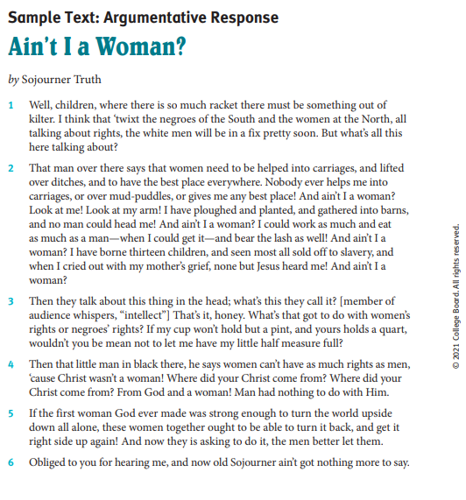

Working From the Text

1. Reread the lines that you highlighted. Then create a “reverse outline” of the three objections made to giving women the right to vote. Then outline the use of logic in response to the objections.

Objection 1:

Response:

Objection 2:

Response

Objection 3:

Response

1. What language in the speech is particularly powerful or convincing?

Check Your Understanding

What is the effect of repeating the question, “Ain’t I a woman?” What is implied by that question?

*For the purpose of this assignment, we are skipping activities 2 and 3 which require group/class writing.

Activity 4: Independent Writing

WRITING PROMPT: Locate a published, publicly expressed claim (e.g., an op-ed piece, a letter to the editor, etc.) that presents a structured argument and that inspires you to respond with a rebuttal. Then respond to the ideas expressed in the piece in a well-crafted letter or essay. Review the writing steps from the class-constructed response, and apply them to the response that you write independently.

1. Create a reverse outline of the text to be sure that you understand the important points.
2. Brainstorm possible responses and evidence that could be used to argue against this position.
3. Conduct research to augment your bank of evidence. Be mindful of selecting credible, unbiased, accurate sources of relevant, valid, and reliable evidence.
4. Generate an outline for your response.
5. Determine a tone and persona to promote in the response.
6. Draft an introduction or opening, body paragraphs, and a conclusion or closing.
7. Remember to include transitions within and between paragraphs.
8. Review your work and revise as necessary. Look for opportunities to exploit rhetorical appeals and promote a deliberate persona.
9. Edit for mistakes in spelling, punctuation, grammar, etc., and produce a final draft.

Refer to the Scoring Guide for this writing task—it will help you understand where to focus your attention and efforts.

Planning and Prewriting:

1.

|  |  |
| --- | --- |
| Claims | Potential Rebuttals and Evidence that Could be Employed to Respond to this Claim |
|  |  |
|  |  |
|  |  |

2. Synthesize this information and select the most relevant and persuasive responses and evidence for inclusion in the rebuttal.

3. To augment your evidence, spend time researching online sources as well as conducting informal interviews. Search for both primary and secondary sources. Your goal here is to search out information that represents the entire range of relevant teenage perspectives—not just your own.

4. Once you have found additional sources, consider their credibility, bias, and accuracy. Evidence from your sources should be relevant, valid, and reliable. Ask the following questions:

* Relevant: Is the information timely and closely tied to the rebuttal?
* Valid: Does the information appear to be legitimate? In what ways could this evidence be used to support the ideas generated for response?
* Reliable: Are the author’s name and qualifications clearly identified? Is the information from a respected source or publication?

If you deem your new information to be relevant, valid, and reliable, add the information to your brainstorm list so you can accurately represent these viewpoints in your class-constructed text.

Drafting:

5. Draft the introduction, or opening paragraph, of the response.

6. Draft the body paragraphs and conclusion or closing.

Resources:

The full activities are found within the English 4 Writers Workshop Student Edition. Pages 15-26.

